(Approx. 475 words)

New to the Library

Google Apps Made Easy – Learn to Work in the Cloud
Author: Terry Flanagan, Club Librarian, GVR Computer Club, AZ
October 2019 issue, Greenbytes
www.ccgvaz.org
Newsletter (at) ccgvaz.org
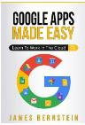
Just added to the club library is GOOGLE APPS MADE EASY – Learn To Work In The Cloud. Google Apps is Google’s response to Microsoft Office and LibreOffice. The table below lists the various functions and the names used.

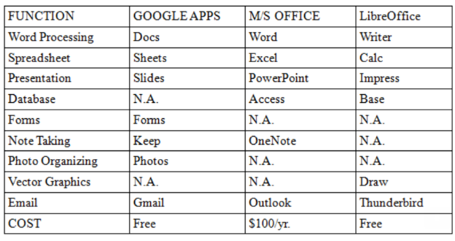
What makes Google Apps different? First and foremost Google Apps are web based. You do not download and install a program on your computer. You use your web browser, preferably Google Chrome, to go to www.google.com and log into your account and there they are. You do not have to be concerned with updates, maintenance, and backup issues. They are also platform or operating system independent. It does not matter if you are using a M/S Windows, Apple MAC or Linux computer, an Android smart phone, iPhone or iPad. The applications and your files are there in the cloud for you to access from wherever you are.

There are several advantage and disadvantages to working in the cloud. Being on the cloud makes it easier to share your files with others, which makes collaboration easier. There is no need to send email attachments back and forth or copy files onto flash drives. Also, all of your data will be consistent between your devices. If you make changes in Google Docs on your PC and later open the file on your iPad the changes are there. Even if you save the file locally to your computer it will be synchronized to the cloud version. The disadvantages are that you must have an internet connection since most of the things you will do with these apps are cloud-based and done online. The applications do not have as many features as the other office suites and some may have security concerns about their data being on the cloud.

From the chart above, you will note that each office suite has applications that the other does not. Google Apps does not have a database module, but this is not a frequently used application by home users. Many common database functions can be handled by a spreadsheet. M/S Office and LibreOffice do not have a photo editing module, but there are a number of good stand-alone programs to perform those tasks.

Google Forms stands out as a unique application. Forms does what the name implies. You can easily create forms to gather information or take surveys. The data is automatically transferred to a spreadsheet and reports created to summarize the results and display them in easy to understand charts.

One final point to mention – notice the bottom line in the chart above. Google Apps are free along with 15 gigabytes of cloud file storage. More space is available for a fee.

